**Project – Even Semester**

**Human Computer Interraction**

Name : Arya Nathan Bara

Student ID : 2602064222

Major : Computer Science

Class : BB01

Code – Lecturer : JEREMY SAPUTRA TATUIL- MY-23-1

Code – Course : COMP6800001 – LAB HCI



Good evening to whoever is reading this, here is my documentation. This is my landing page, where I mostly highlight the watches on promo such as Formica.

* **Navbar**

Here the navbar leads to the pages that was instructed to be made (based on the project evaluation)

* **Footer**

The footer has my name and copyright, and some social media that I have (you can click it and follow me on IG)

* **Landing Page**

Here I displayed the most interesting video I can find on youtube and also I displayed some pictures too, the buy now will lead to the product page according to their categories (If it is going to be deployed as a real web)

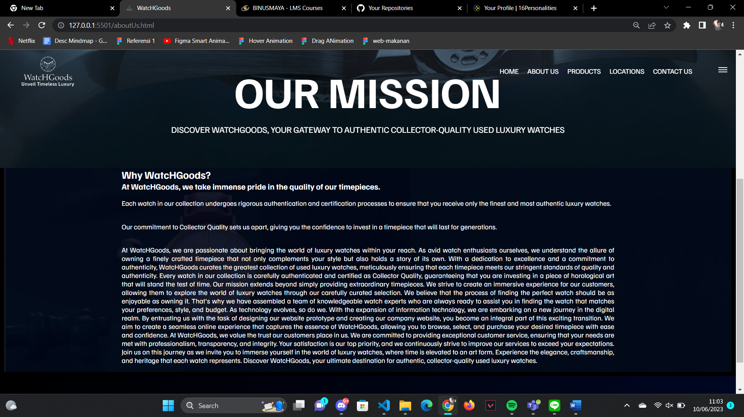

For the About us section I made it a little basic, our mission, why should you choose us, etc.

For the navbar and the footer, it’s the same as the one in the homepage.

For the products part I used the same animation and font as the one in about us.

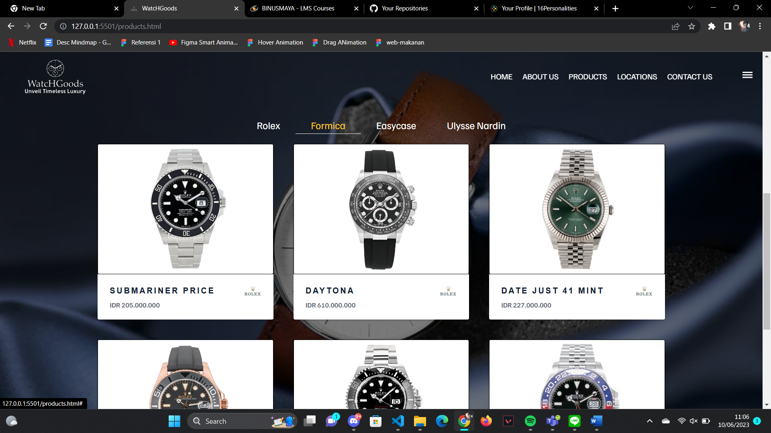

And to display the products I used a card with animations to tell the details of a product. And I made some categories ( I didn’t make the pages) but if it was a real web it will show the products according to its brand.

For the location page, I used the same card animation as the one on products, but there is a stats counter that shows how many outlets that watchgoods has, their awards, and business partners.

For the contact us part I made it fairly simple with some animations and I also make it so that the background to continue ( if the image is not large enough to cover an entire page). Also I used some java script validation before the info can be submitted

I also made the page to be responsive ( only show the logo with a hamburger when its under 800px )